REQUEST FOR QUOTATION (RFQ) INSTRUCTIONS
Date: 23.09.2026
SECTION 1: REQUEST FOR PROPOSALS FOR THE PROCUREMENT OF PSYCHOTROPIC AND PEP MEDICINES
Interested Bidders can quote for the items below.
Psychotropic & PEP Medicines
SN | Medications | Unit | Quantity | Expiry Date
1 | Amitriptyline (25 mg) | Tablet (500) | 384 | Not less than 14- 18 months from the date of supply.
2 | Chlorpromazine (100 mg) | Tablet (1000) | 384 | Not less than 14- 18 months from the date of supply.
3 | Carbamazepine (200 mg) | Tablet (1000) | 64 | Not less than 14- 18 months from the date of supply.
4 | Haloperidol (5 mg) | Tablet (1000) | 80 | Not less than 14- 18 months from the date of supply.
5 | Fluoxetine (20 mg) | Capsule (30) | 96 | Not less than 14- 18 months from the date of supply.
6 | Tenofovir + Lamivudine + Dolutegravir (TLD) (300mg/300mg/50mg) | Capsule (90) | 80 | Not less than 14- 18 months from the date of supply.
7 | Azithromycin (250 mg) | Capsule (6) | 192 | Not less than 14- 18 months from the date of supply.
8 | Ceftriaxone (1g I.v) | Pack (1 Vial) | 192 | Not less than 14- 18 months from the date of supply.
9 | Metronidazole (400 mg) | Tablet (10) | 96 | Not less than 14- 18 months from the date of supply.
10 | Benzathine Penicillin (2.4 MU 1M Stat) | Vials (10) | 80 | Not less than 14- 18 months from the date of supply.
11 | Paracetamol (500 mg) | Tablet (96) | 384 | Not less than 14- 18 months from the date of supply.
12 | Povidone Iodine (Topical antiseptics) (2 litre) | 2-lliter Gallon | 96 | Not less than 14- 18 months from the date of supply.
13 | Tetanus toxoid (0.5 ml) | Ampoules (50) | 96 | Not less than 14- 18 months from the date of supply.

Albarka Health Spring Foundation (AHSF) kindly requests your quotation for the procurement of psychotropic and PEP medications as detailed in Annex 1 of this RFQ instruction.

This Request for Quotation comprises the following documents:

Section 1: This request letter.
Section 2: RFQ Instructions and Data
Annex 1: Schedule of Requirements
Annex 2: Quotation Submission Form
Annex 3: Technical and Financial Offer

When preparing your quotation, please refer to the RFQ Instructions and Data.

Note: Quotations must be submitted using Annex 2: Quotation Submission Form (AHSF RFQ form) and Annex 3: Technical and Financial Offer, following the method and by the date and time specified. If the need for additional information arises, please you are advised to use your company letterhead, which must be properly signed and stamped by an authorized person.

You are responsible for submitting your quotation by the deadline.

Quotations received after the submission deadline, for whatever reason, will not be considered.

Thank you. We look forward to receiving your quotations.

Sincerely yours,
AHSF Procurement Team

SECTION 2: RFQ INSTRUCTIONS AND DATA
Deadline for Submission  of Quotation | 7th October 2026, 11:59 PM
Method of Submission | Quotations must be submitted as follows:  ☒ Email  Bid submission address: ahsf.tenders@ahsfng.org  and copy this email to ahsfprocurement.tenders@gmail.com  This is very important!  • File Format: PDF format (links are not allowed)  • File names must be a maximum of 60 characters long and  must not contain any letter or special character other than  from the Latin alphabet/keyboard.  • All files must be free of viruses and not corrupted.  • Max. File Size per transmission: 15MB  • Mandatory subject of email: Must reflect the subject you are bidding for  • Multiple emails must be identified by indicating in  the subject.  It is recommended that the entire Quotation be consolidated into  as few attachments as possible.  For physical submission of bids;  Hard copy submission can be done at the AHSF office located at:  House No.2, Road Safety Quarters, Old Airport, Sokoto State, Nigeria.  This must be in a sealed envelope, with all relevant documents.
Cost of preparation of  quotation | AHSF shall not be responsible for any costs associated with a Supplier’s preparation  and submission of a quotation, regardless of the outcome or the manner of  conducting the selection process.
Conflict of Interest | AHSF encourages every prospective Supplier to avoid and prevent conflicts of interest by disclosing to AHSF if you, or any of your affiliates or personnel, were involved in the  preparation of the requirements, design, specifications, cost estimates, and other information used in this RFQ.
General Conditions of  Contract | Any Purchase Order or contract that will be issued as a result of this RFQ shall be subject to the AHSF General Conditions of Contract for the provision of goods/services/transportation/medical services.
Eligibility | Bidders shall have the legal capacity to enter into a binding contract with AHSF and to deliver in the country, or through an authorized representative.
Duties and taxes | It is in AHSF's policy that:  ☒ Withholding tax (WHT) shall be deducted from the total cost.
Documents to be submitted | Bidders shall include the following documents in their quotation:  *A valid company registration evidence from the Corporate Affairs Commission (CAC) certificate.  *Valid MBBS, Pharmacy License, or Pharmaceutical Distribution License.  *Valid Tax Identification Number (TIN) and Recent Tax Clearance  *CVs of key lead/supervisory staff.  *Evidence of relevant experience supplying healthcare or pharmaceutical products within the last 2 years.  *At least two (2) references from reputable organizations previously served.
Quotation validity period | Quotations shall remain valid for 90 days from the deadline for the Submission of the Quotation.
Price variation | No price variation due to escalation, inflation, fluctuation in exchange rates, or any other market factors shall be accepted at any time during the validity of the quotation after the quotation has been received.
Partial Quotes | Not Permitted
Payment Terms | - 100% payment will be made within 30 days after receipt of goods, works, and/or services and submission of payment documentation.  - The supplier must have the financial resources to commence and complete the job within the stipulated timeline.  - Payment will be made only through bank transfer.
Contact Person for  correspondence,  notifications and  clarifications | Focal Person: AHSF Procurement Department  E-mail address: ahmed.s@ahsfng.org  Attention: Quotations shall not be submitted to this address but to the address for quotation submission above.
Clarifications | Bidders are advised that requests for clarification will not be accepted within 2 days of the submission deadline. Responses to clarification requests will be emailed to the respective bidder.
Evaluation criteria | ☒Full compliance with all requirements as specified  ☒Full acceptance of the General Conditions of Contract  ☒Earliest Delivery /shortest lead time  ☒Competitive and transparent pricing  ☐Others (for ex, environmental criteria/considerations, etc)
Right not to accept any  quotation | AHSF is not bound to accept any quotation, nor award a contract or Purchase Order
Right to vary requirements at the time of award | At the time of award of the Contract or Purchase Order, AHSF reserves the right to vary (increase or decrease) the quantity of services and/or goods by up to a maximum of 25% of the total offer, without any change in the unit price or other terms and conditions.
Type of Contract to be  awarded | Purchase Order (PO) with respect to the accepted bids.
Expected date for contract  award. | Not later than 19-October-26
Policies and procedures | This RFQ is conducted in accordance with the Policies and Procedures of AHSF

ANNEX 1: SCHEDULE OF REQUIREMENTS
Delivery Requirements
Delivery Requirements
Delivery date and time | Bidder shall deliver the service within 7 days after the Purchase Order (PO) is signed.
Exact Address(es) of Delivery Location(s) | Albarka Health Spring Foundation, [House No. 2, Road Safety Quarters, Old Airport, Sokoto State, Nigeria].
Warranty, After-sales service, and local service support requirements | The Contractor remains responsible for the quality and condition of the supplies until they are certified and accepted by the inspection team provided by AHSF, after which a Goods Received Note (GRN) and a Certificate of Job Completion are issued.

Evaluation Criteria
A. Preliminary Examination of Bids (Pass/Fail criteria)
This stage of the evaluation is to assess the document formality required for each bidder with pass or fail criteria before undertaking their detailed examination or evaluation. Confirmation will be conducted one by one to verify whether the submitted documents and format conform to the requirements outlined below.
In case of no submission or the absence of any of the required documents deemed important, such Bidder shall be disqualified at this stage.
Eligibility Requirement | Document required | Importance | Criteria
Annex 2: Quotation Submission Form duly completed and signed (and preferably stamped) | Provide AHSF Quotation submission form (Annex 2) | High | Pass/Fail
Annex 3: Financial Offer in line with the BOQ (Annex 1), duly completed and signed (and preferably stamped). | Provide Annex 3 (Print out and fill) | High | Pass/Fail
Evidence of registration with the Corporate Affairs Commission (CAC) | Provide a valid CAC Certificate | High | Pass/Fail
Valid MBBS, Pharmacy License, or Pharmaceutical Distribution License. | Provide a valid MBBS, Pharmacy License, or Pharmaceutical Distribution License. | High | Pass/Fail
Evidence of tax compliance | Provide at least a 2025 Tax Clearance Certificate (TCC). | High | Pass/Fail

Bidders must achieve a rating of "pass" in all categories to move forward to the technical assessment.
B. Technical Examination (Weighted criteria):
Technical Qualifying criteria are the minimum requirements that will be evaluated on a weighted basis. This will determine whether the Bid is substantially responsive to the technical requirements. All bids will be checked for substantial responsiveness to the technical requirements.
The technical evaluation accounts for 70 points (70%) out of the total combined score (technical + financial) of 100 Points.
 | Criteria | Requirement | Rating
A | Similar experience: Successful similar experience in terms of equivalent nature and complexity carried out on behalf of hospitals, INGOs or NGOs, or other reputable organizations in Nigeria. | Evidence of relevant experience supplying healthcare or pharmaceutical products within the last 2 years. | 35 Points
A | Bidder must provide a copy of evidence, such as a Purchase Order, Contract, or Award Letter | Note: No Submission will be scored a Zero | 35 Points
B | Financial Capability: Most recent audited financial statements and the ability to procure stock upfront.  A statement of account for 2025 will also suffice, if you would be willing to share. | Audited financial statements (at least for 2024)  Evidence of liquidity (ability to procure stock upfront) | 25 Points
B |  | Note: No Submission will be scored a Zero | 25 Points
C | Logistics & Delivery Capability: Lead-time commitments and best delivery options.  (A realistic delivery timeline is required as there will be penalties for timeline violation). | If the service level is within the AHSF proposed delivery timeline. | 20 Points
C |  | Note: No Logistics & Delivery Capability will be scored a Zero | 20 Points
D | CVs of key Lead/Supervisory staff. | Bachelor’s degree in pharmacy, MBBS, and related fields with a minimum of 5 years’ experience and above in relevant activity. | 20 Points
D | Required: |  | 20 Points
D | A detailed CV should be presented showing the qualifications of all staff. |  | 20 Points
D | A valid pharmacy license or pharmaceutical distribution license must accompany the CVs | Note: No Submission will be scored a Zero | 20 Points

Only bidders who achieve a technical evaluation score of 70% or higher will proceed to the financial evaluation phase.

C. Detailed Examination of Bids (Financial Examination)
Only the Financial Proposal of bidders that obtain an overall Pass in the Preliminary evaluation and a minimum of 70% in the technical evaluation shall undergo the financial evaluation.
The financial evaluation accounts for 30 points (30%) out of the total combined score (technical + financial) of 100 points.
The lowest Financial Proposal (F1) shall be given a financial score (Sf) of 100 points.
The financial scores (Sf) of the other Financial Proposals shall be computed based on the formula:
Sf = 100 xF1/F
Where:
Sf - is the financial score of the Financial Proposal under consideration.
F1 - is the price of the lowest Financial Proposal, and
F - is the price of the Financial Proposal under consideration.
The proposals shall then be ranked according to their combined (Sc) technical (St) and financial (Sf) scores using the weights.
(T = the weight given to the Technical Proposal = 0.70; F = the weight given to the Financial Proposal = 0.30; T + F = 1).
Sc = St x T% + Sf x F%

ANNEX 2: QUOTATION SUBMISSION FORM

Bidders are requested to download and complete this form, including the Company Profile and Bidder’s Declaration, sign it, and return it as part of their quotation along with Annex 3: Financial Offer.
The Bidder shall fill in this form following the instructions indicated. No alterations to its format shall be permitted, and no substitutions shall be accepted.
Download the RFQ: Click Here
Note: If the need for additional information arises, please you are advised to use your company letterhead, which must be properly signed and stamped by an authorized person.

Note: Please ensure that BIDDER’S DECLARATION OF CONFORMITY is duly filled, signed, and attached to the RFQ form downloaded

BIDDER’S DECLARATION OF CONFORMITY (Please tick Yes or No as applicable)
YES | NO
☐ | ☐ | On behalf of the Supplier, I hereby represent and warrant that neither the Supplier, nor any person having powers of representation, decision-making, or control over it or any member of its administrative, management, or supervisory body, has been the subject of a final judgment or final administrative decision for one of the following reasons: bankruptcy, insolvency or winding-up procedures; breach of obligations relating to the payment of taxes or social security contributions; grave professional misconduct, including misrepresentation, fraud; corruption; conduct related to a criminal organization; money laundering or terrorist financing; terrorist offenses or offences linked to terrorist activities; child labour and another trafficking in human beings, any discriminatory or exploitative practice, or any practice that is inconsistent with the rights outlined in the Convention on the Rights of the Child or other prohibited practices; irregularity; creating or being a shell company.
☐ | ☐ | On behalf of the Supplier, I further represent and warrant that the Supplier is financially sound and duly licensed.
☐ | ☐ | On behalf of the Supplier, I further represent and warrant that the Supplier has adequate human resources, equipment, competence, expertise, and skills necessary to complete the contract fully and satisfactorily, within the stipulated completion period, and in accordance with the relevant terms and conditions.
☐ | ☐ | On behalf of the Supplier, I further represent and warrant that the Supplier complies with all applicable laws, ordinances, rules, and regulations.
☐ | ☐ | On behalf of the Supplier, I further represent and warrant that the Supplier will in all circumstances, act in the best interests of AHSF.
☐ | ☐ | On behalf of the Supplier, I further represent and warrant that no official of AHSF or any third party has received from, will be offered by, or will receive from the Supplier any direct or indirect benefit arising from the contract.
☐ | ☐ | On behalf of the Supplier, I further represent and warrant that the Supplier has not misrepresented or concealed any material facts during the contracting process.
☐ | ☐ | On behalf of the Supplier, I further represent and warrant that the Supplier will respect the legal status, privileges, and immunities of AHSF as an intergovernmental organization.
☐ | ☐ | On behalf of the Supplier, I further represent and warrant that neither the Supplier nor any persons having powers of representation, decision-making, or control over the Supplier or any member of its administrative, management, or supervisory body are included in the most recent Consolidated United Nations Security Council Sanctions List (the “UN Sanctions List”) or are the subject of any sanctions or other temporary suspension. The Supplier will immediately disclose to AHSF if it or they become subject to any sanction or temporary suspension.
☐ | ☐ | On behalf of the Supplier, I further represent and warrant that the Supplier does not employ, provide resources to, support, contract, or otherwise deal with any person, entity, or other group associated with terrorism as per the UN Sanctions List and any other applicable anti-terrorism legislation.
☐ | ☐ | On behalf of the Supplier, I further represent and warrant that the Supplier will apply the highest ethical standards, the principles of efficiency and economy, equal opportunity, open competition, and transparency, and will avoid any conflict of interest.
☐ | ☐ | It is the responsibility of the Supplier to inform AHSF immediately of any change to the information provided in this Declaration.
☐ | ☐ | On behalf of the Supplier, I certify that I am duly authorized to sign this Declaration and, on behalf of the Supplier, I agree to abide by the terms of this Declaration for the duration of any contract entered into between the Supplier and AHSF.
☐ | ☐ | AHSF reserves the right to terminate any contract between AHSF and the Supplier, with immediate effect and without liability, in the event of any misrepresentation made by the Supplier in this Declaration.

NOTE: This form is mandatory to fill in and sign by every vendor who submits the quotation

Signature: _________________________________________________
Name: ____________________________________________________
Title: _____________________________________________________
Date: _____________________________________________________
ANNEX 3: TECHNICAL AND FINANCIAL OFFER - WORKS
Bidders are requested to complete this form, sign it, and return it as part of their quotation along with the Annex 2 Quotation Submission Form. The Bidder shall fill in this form following the instructions indicated. No alterations to its format shall be permitted, and no substitutions shall be accepted.
Name of Bidder: ________________________________________________________________________________

Address of Bidder: ____________________________________________ | Date: ________________________

Financial Offer
Description of Works | UOM | Qty | Cost
Total Cost for the Purchase of Psychotropic & PEP Medicines | Lumpsum | 1

Compliance with Requirements
You Responses
 | Yes, we will comply | No, we cannot comply | If you cannot comply, pls. indicate a counterproposal
Delivery Lead Time | ☐ | ☐
NAFDAC certification/registration for all products offered | ☐ | ☐
Validity of Quotation | ☐ | ☐
Payment terms | ☐ | ☐
Above 18 Months shelve life for all products supplied | ☐ | ☐

I, the undersigned, certify that I am duly authorized to sign this quotation and bind the company below if the quotation is accepted.
The exact name and address of the company  Company Name:  Address:  Phone No.:  Email Address: | Authorized Signature:  Date:  Name:  Functional Title of Authorized  Signatory:  Email Address:

Appendix
Sample images of the drugs; they must be from a reputable manufacturer and be NAFDAC registered. Shelf-life must be above 18 months from the supply date.
PSYCHOTROPIC DRUG |  |  | Some Recommended Manufacturers | Samples
Name | Size | Unit | Some Recommended Manufacturers | Samples
Amitriptyline | 25mg | tablets | AdvaCare Pharma, Apotex, LGM Pharma, Marcan Pharmaceuticals, Ecomed Pharma | 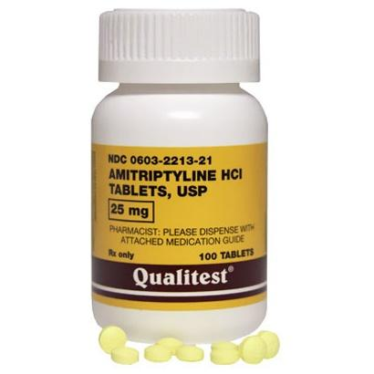
Chlorpromazine | 100mg | tablets | AdvaCare Pharma, Kreative Organics, Raks Pharma, and Biophore India | 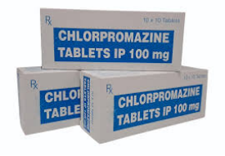
Carbamazepine | 200mg | tablets | Sandoz (Canada), AdvaCare Pharma, CTX Lifesciences (API), Actiza Pharmaceutical, Chemidex Pharma, Essential Pharma, Ranbaxy, Novartis Pharmaceuticals | 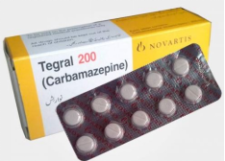
Haloperidol | 5mg | tablets | Janssen Pharmaceutica, Vamsi Labs Limited (India), LGM Pharma (USA), Mankind Pharma (India), RPG Life Sciences (India), Flagship Biotech International (India) | 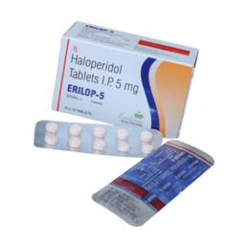
Fluoxetine | 20mg | Capsule | AdvaCare Pharma, Sandoz, Apnar Pharma, Aurobindo Pharma, Cadila Pharmaceuticals, Teva Pharmaceuticals, Shanxi Qianyuan Pharmaceutical | 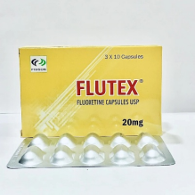

PEP Drugs |  |  | Recommended Manufacturers | Samples Image
Name | Size | Unit | Recommended Manufacturers | Samples Image
Tenofovir + Lamivudine + Dolutegravir (TLD) (300mg/300mg/50mg) | (300mg/300mg/50mg) | Capsule (90) | Aurobindo Pharma, Laurus Labs, Emcure Pharmaceuticals, Strides Pharma Science, and Hetero Labs | 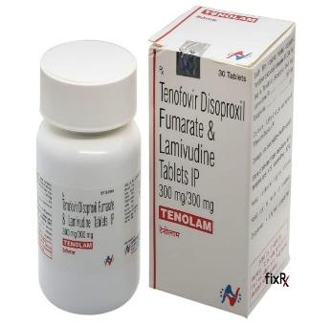
Levonorgestrel (1.5mg) | (1.5mg) | Tablet (1) | 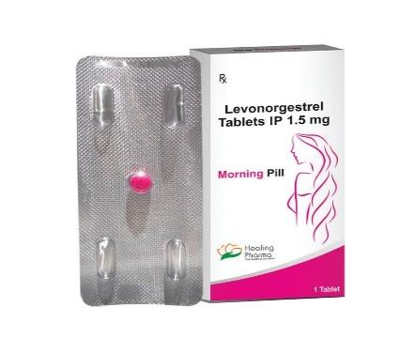  Crescent Pharma, Omicron Pharma, AdvaCare Pharma, HLL Lifecare Ltd, Lupin Healthcare, Xiromed, and Montage Laboratories
Azithromycin (250mg) | (250mg) | Tablet (6) | 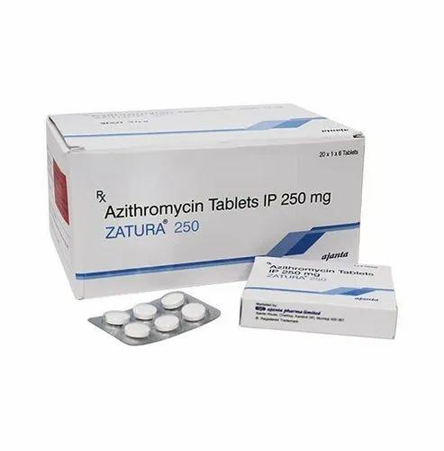  Pfizer, Cipla Ltd, Aurobindo Pharma (Milpharm Ltd), Alembic Pharmaceuticals, Athene Chemicals, Therawin Formulations, and AstraEureka Pharmaceuticals.
Ceftriaxone (1g I.v) | (1g I.v) | Vial | 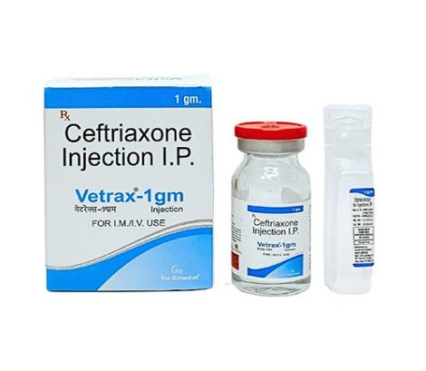  Roche, Pfizer/Hospira, Sandoz, Cipla, Alkem Laboratories, Wockhardt UK Ltd, AdvaCare Pharma, Reyoung Pharmaceutical CO., LTD., MarleyShree Pharmaceutical Company, MC Foris Pharmaceuticals Limited, Kenneth Global Investment Pharmacy Limited, and Venus Remedies Ltd.
Metronidazole (400mg) | (400mg) | Tablet (10) | 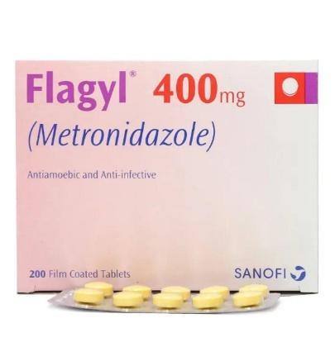  Unique Pharmaceuticals Limited, Sanofi, Aurobindo Pharma / Milpharm, Crescent Pharma, Sophia Pharmaceutical Company, Alphine Pharmaceuticals, Sun Pharma UK Ltd, Teva UK Ltd, Viatris UK Healthcare Ltd, and various, smaller, local manufacturers (e.g., in Bangladesh/India).
Benzathine Penicillin (2.4 MU 1M Stat) | (2.4 MU 1M Stat) | Vial | Ando Pharma, AdvaCare Pharma, Centurion Healthcare, Wellona Pharma, Lavina Pharma, North China Pharmaceutical | 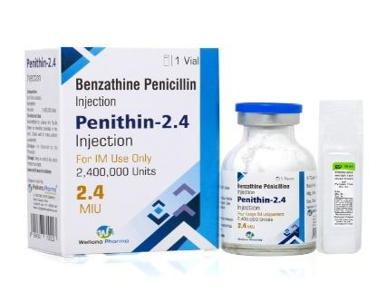
Paracetamol (500mg) | (500mg) | Tablet (96) | 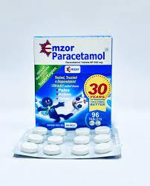  Unique Pharmaceuticals, Emzor Pharmaceutical, Sygen Pharmaceuticals, Funag Pharmaceutical, May & Baker, De-Shalom Pharmaceutical Lab, Shalina Healthcare
Povidone Iodine (Topical antiseptics) |  | (2litre) | Jawa International Ltd, Greenwich Healthcare Limited | 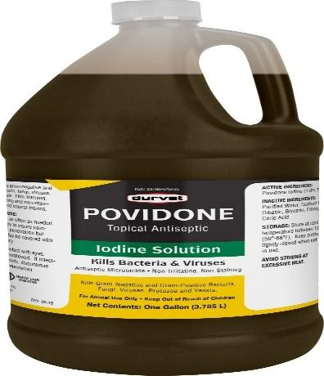
Tetanus toxoid (0.5ml) | (0.5ml) | Ampoules | 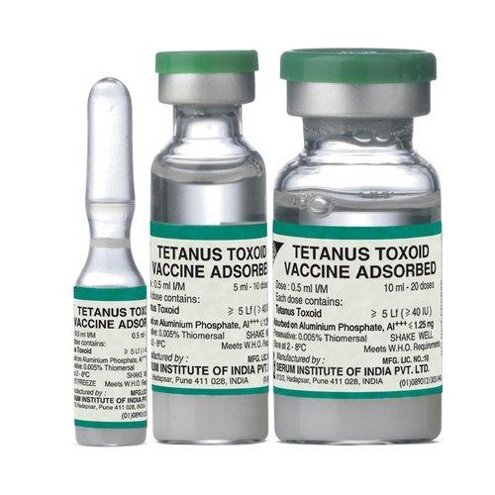  Amson Vaccines & Pharma, Dano Vaccines, GlaxoSmithKline, Serum Institute of India

